**Guidelines for Data Visualization and Analysis Project**

**About the Project:**

In this project, you will be working with a dataset from the Superstore, aiming to answer 30 scenario-based questions through data visualisation and analysis. Your objective is to select the best chart for each question, explain your choice. This project will showcase your proficiency in data visualisation, critical thinking, and effective communication.

**Skills Required:**

* Proficiency in data visualisation concepts and techniques.
* Familiarity with Tableau or a similar data visualisation tool.
* Strong analytical and problem-solving skills.
* Ability to choose appropriate charts based on data characteristics and question requirements.
* Clear and concise communication skills.

**Deliverables:**

* A Google document containing solutions to the scenario based questions including the screenshot of relevant chart picked for each scenario, presented in a concise and well-structured format. Make sure to provide explanations that highlight your problem-solving skills.

**Rubrics for Assessment:**

Question Responses:

* Accuracy and completeness of answers for all 30 questions.
* Clear and concise explanations that address the question's context.

Chart Selection and Explanation:

* Thoughtful rationale for choosing specific chart types.
* Justification based on data characteristics, context, and communication goals.

Creative Enhancements:

* Effective use of creative elements to enhance visualisation quality.
* Enhancements that contribute to better understanding or engagement.

**Note**:

* Duplicate this document and proceed to write your solutions.
* For each scenario and question, provide a justification for the choice of chart type. Explain why it is the best option to visualise the data effectively.
* Attach screenshots of the charts you have created in Tableau for each scenario and question using the Superstore dataset. Label them clearly to match the corresponding questions in the Google Document.
* Submit the duplicated google doc file after completion.

Use these guidelines to structure your data visualisation and analysis project. Remember to maintain consistency in your responses, explanations, and visualisation styles. This project will not only demonstrate your skills but also your ability to effectively communicate complex information through visualisations. Good luck!

**Problem Statement: Choose the Best chart for any 30 scenario based questions from Superstore Dataset.**

Imagine you are a data enthusiast aiming to excel in data visualisation and analysis. In this task, you have been given any 30 scenario-based questions derived from the Superstore dataset, and your objective is to provide insightful answers using appropriate charts. For each question, you need to select a chart that best represents the data, explain why you chose that specific chart, and then proceed to build the chosen chart using Tableau.

Your responses should be succinct, organised, and illustrative of your problem-solving capabilities.

**Dataset Link:**

<https://community.tableau.com/s/question/0D54T00000CWeX8SAL/sample-superstore-sales-excelxls>

**Please keep in mind:**

1. **Answer Completion**: Ensure that you furnish answers for all any 30 questions and build charts for them.
2. **Encouraged Creativity**: Don't hesitate to employ visuals, creative elements, or any other innovative approaches to enhance the quality of your responses.

By completing this task effectively, you'll not only demonstrate your proficiency in data visualisation and analysis but also showcase your ability to effectively communicate complex concepts through both text and charts.

**Good luck!**

**Questions:**

1. Which product categories have the highest total sales in the "Superstore" dataset?
2. How is the total sales amount distributed among different product categories?

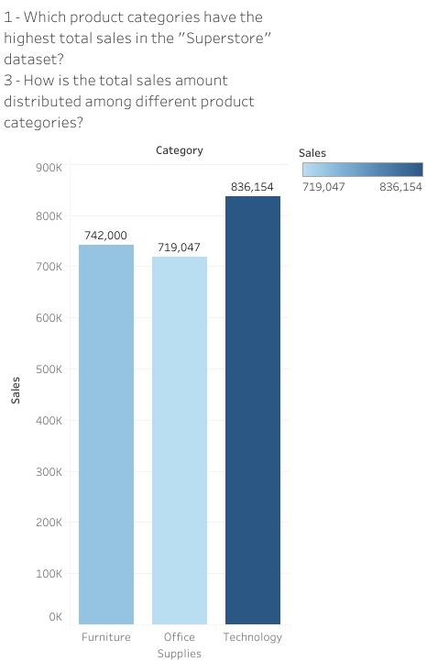

Using this one chart we can answer the above 2 questions. I have used bar charts here as we are doing a categorical comparison of categories on the basis of total sales.it also shows that the technology category has the highest number of total sales.

1. How do the monthly sales amounts change over the course of a year?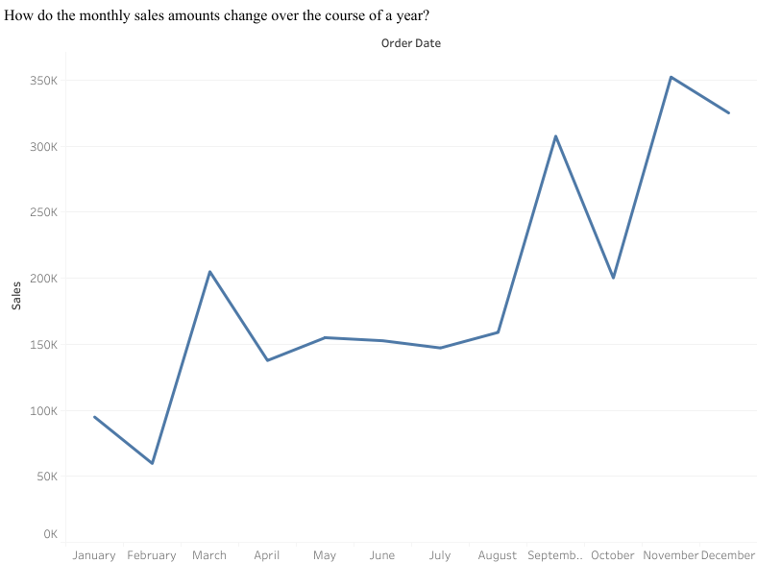

The line chart shows the trends with time properly.

1. Can we analyze the sales performance of individual customers over time?

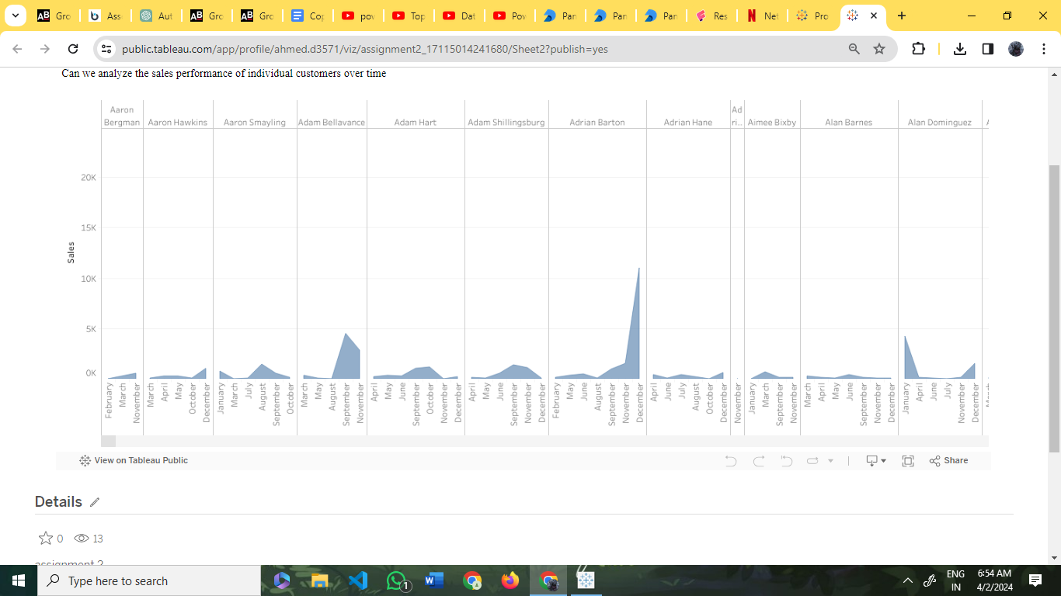

There is a high number of individual customers to analyze their trends one by one would provide multiple charts. The line chart is used to show the trends.

1. How do sales vary based on different days of the week and product categories?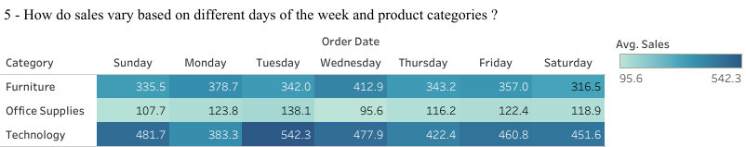

The heat map shows the variation in a single look. The area with or the cell with the darkest region shows the day with the highest no of average sales for that category.

Technology on Tuesday has the highest number of average sales.

1. Can we visualize the sales growth of different product categories over time?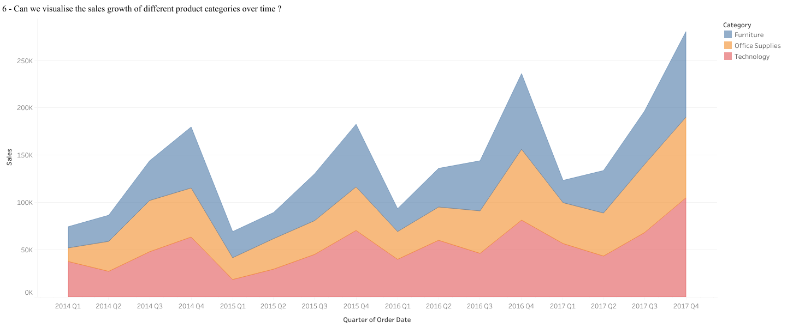

The line chart is used when seeing the growth over time.

The chart shows that in the last 2 4th quarters the total sales increased, and the total sales have increased from the beginning of 2014 to the end of 2017

1. How does the sales distribution vary across different regions in the "Superstore" dataset
2. What is the percentage contribution of each region to the overall sales?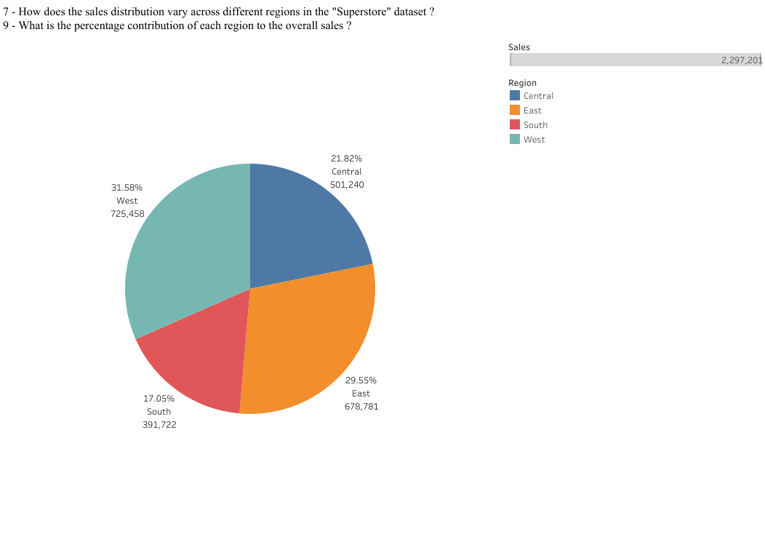

The pie charts show the distribution in a better understanding manner.

We can see the distribution of different regions towards the total sales with the west

having the highest contribution 31.58% in the total no of sales.

1. Can we visualise the composition of profits across various subcategories within different customer segments?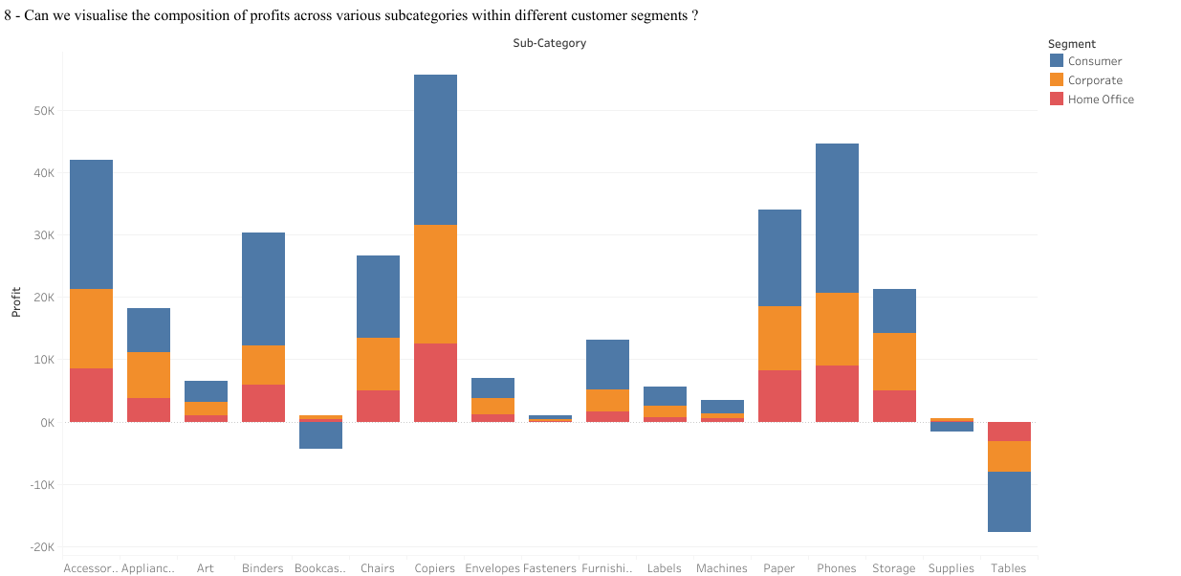

Stacked Bar charts are suitable for comparison, we can see here that the table and supplies category are having losses rather than profits.

1. Can we visualise the profit margins associated with different shipping modes and customer segments?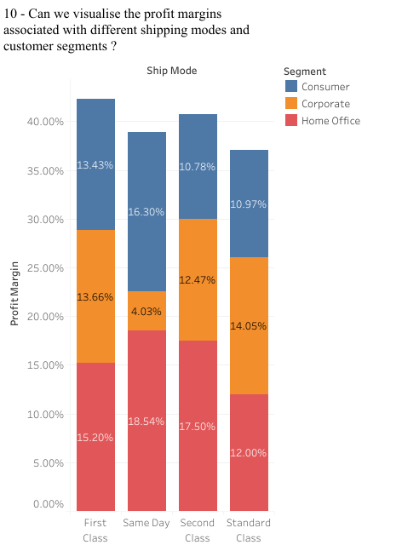

Bar charts are suitable for comparing the profit margins of different categories, such as shipping modes and customer segments, because they allow for easy comparison of values across categories.

1. How long does it take to process orders for different product categories?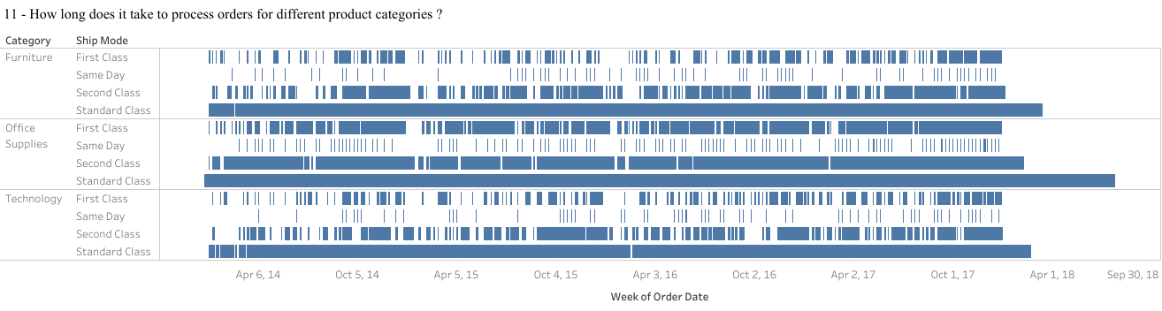

Gantt charts are used to visualize the duration of tasks or processes, making them ideal for showing the processing time of orders for different product categories over time.

1. How do discounts affect overall profit?

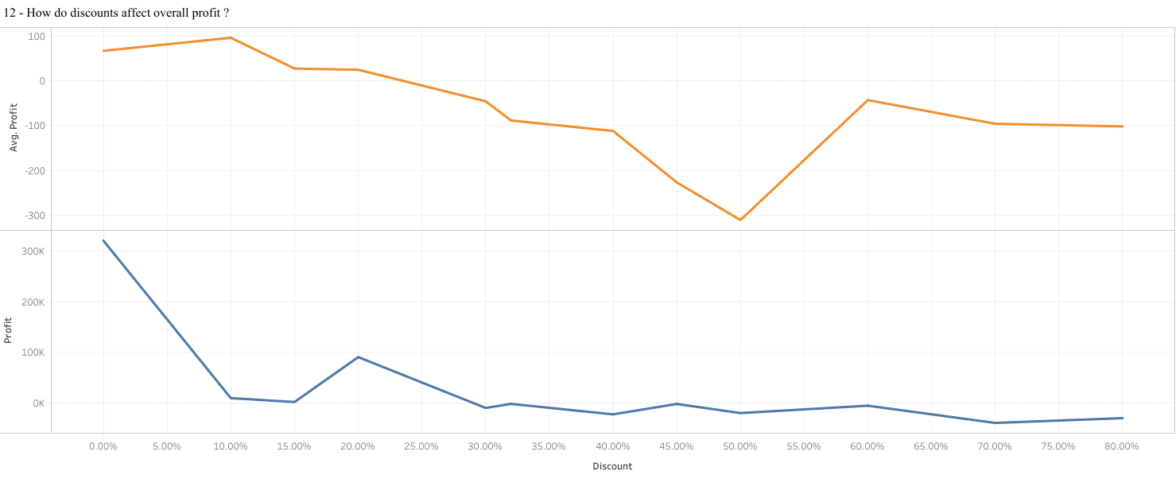

Line charts are effective for showing trends over time, making them suitable for visualizing how discounts affect overall profit by displaying profit trends over time as discount rates vary.

1. Can we visualise the relationship between product sales and profitability for different product categories?

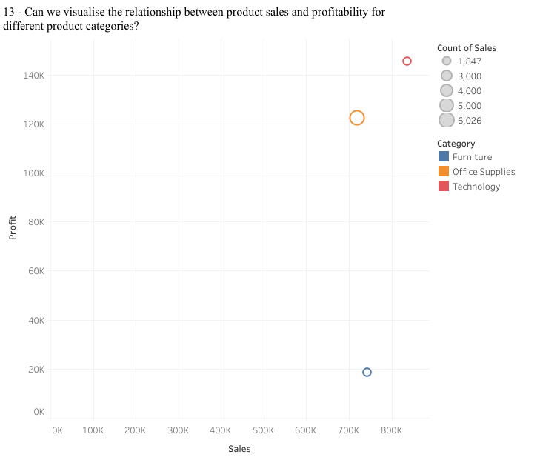

Scatter charts are useful for visualizing the relationship between two variables, making them suitable for showing the relationship between product sales and profitability for different product categories. we can see that even though the count of sales is less the technology category has a higher amount of total sales and profit.

1. What is the distribution of order quantities for products in the dataset?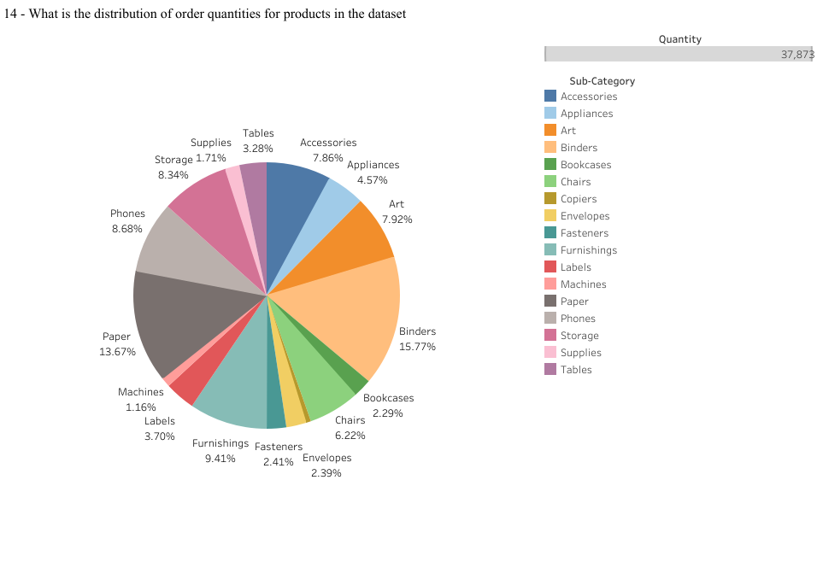

Pie charts are commonly used to represent parts of a whole, making them suitable for displaying the distribution of order quantities for different products in the dataset.

1. How do the profit distributions vary across different product categories?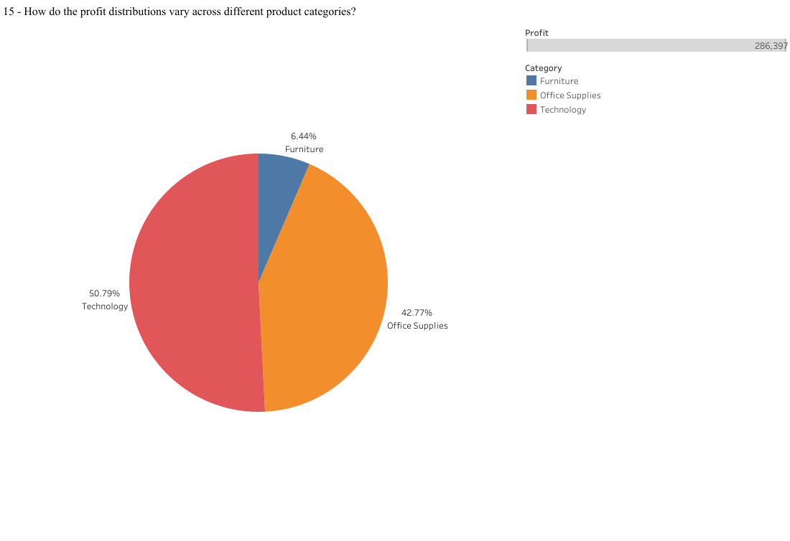

Similar to the previous question, pie charts can effectively represent the distribution of profits across different product categories, allowing for easy comparison of profit distributions.

1. Can we compare the shipping time distributions for different shipping modes?
2. What is the average delivery duration for different regions and ship modes?

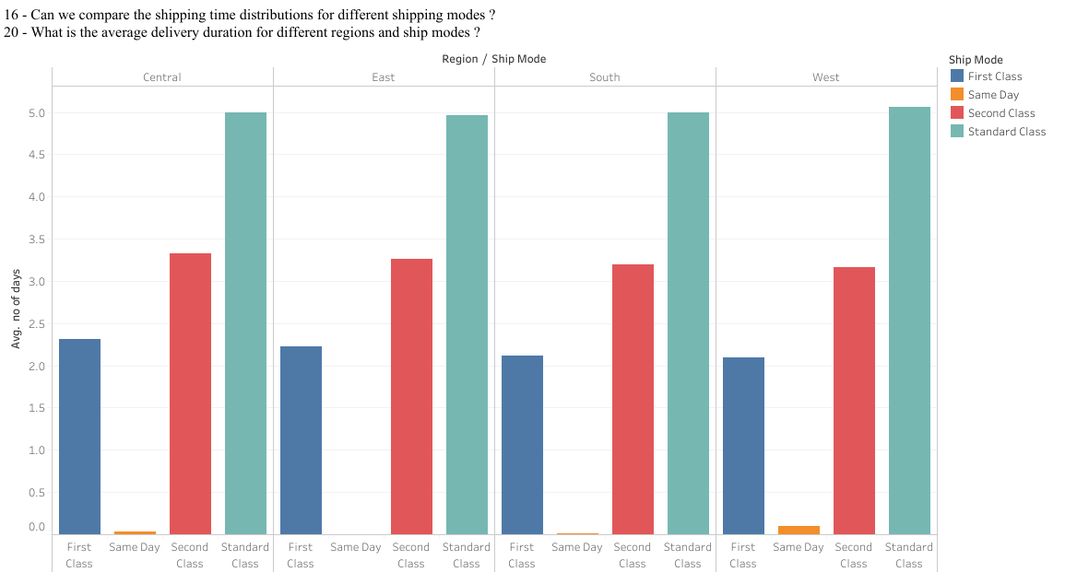

Bar charts are suitable for comparing distributions or frequencies across different categories, making them ideal for comparing shipping time distributions for different shipping modes.

1. What is the monthly trend in the number of orders shipped?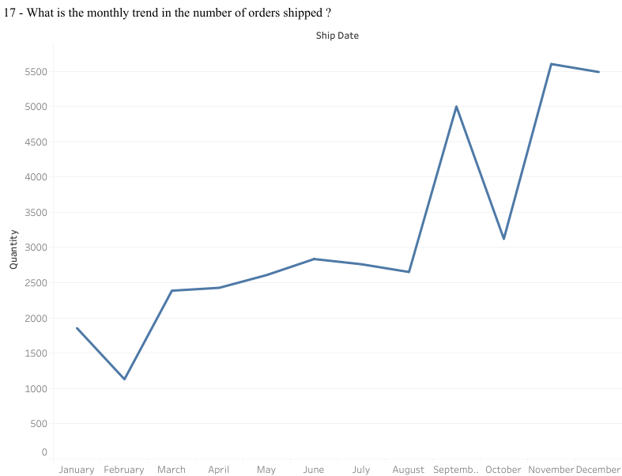

Line charts are commonly used to display trends over time, making them suitable for visualizing the monthly trend in the number of orders shipped.

1. How do different customer segments perform in terms of sales and discount rates?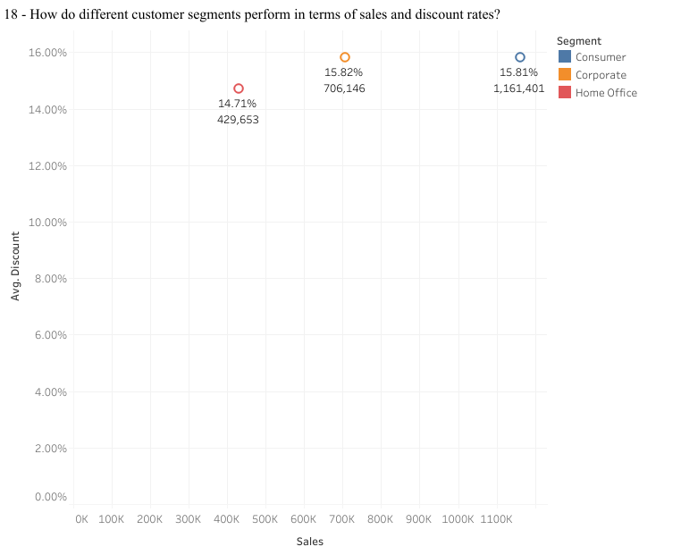

Scatter charts can effectively show the relationship between two variables, making them suitable for comparing different customer segments in terms of sales and discount rates.

1. What are the sales and profit trends across different product subcategories and regions in the Superstore dataset?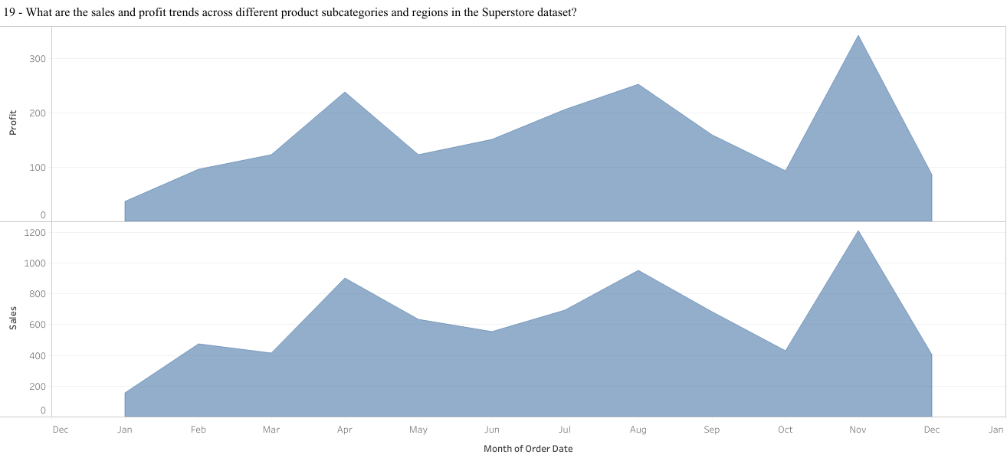

Area charts are suitable for showing trends over time or across different categories, making them ideal for visualizing sales and profit trends across different product subcategories and regions.

1. How has the average order quantity changed over the years for various product categories?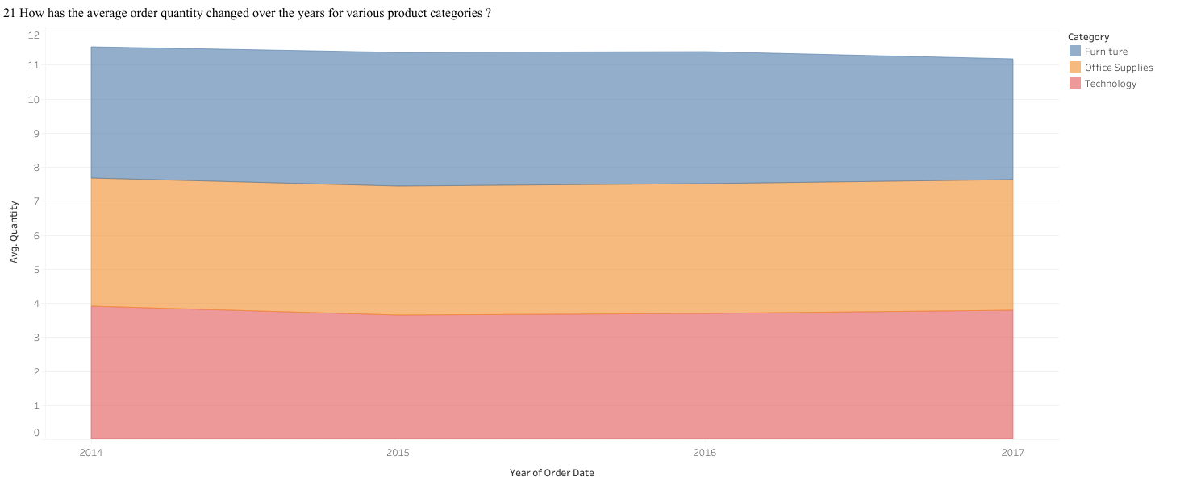

Similar to the previous question, area charts can effectively show trends over time, making them suitable for visualizing changes in the average order quantity over the years for various product categories. but we can see that over the year the number of quantities ordered hasn't changed, much but the total sales have still increased.

1. Can we visualise the correlation between discount rates and order quantities for different customer segments?

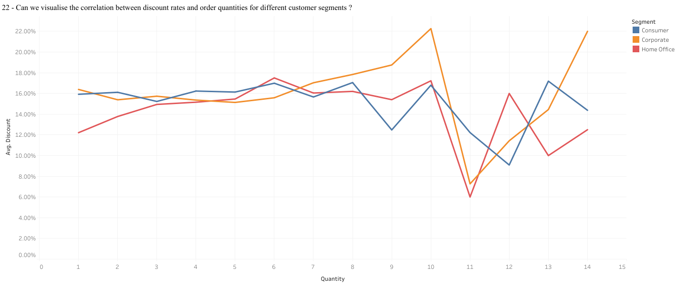

Multiple line charts in a single figure can effectively display the correlation between discount rates and order quantities for different customer segments by showing multiple lines representing each customer segment.

1. What is the proportion of orders returned in each region within the Superstore dataset?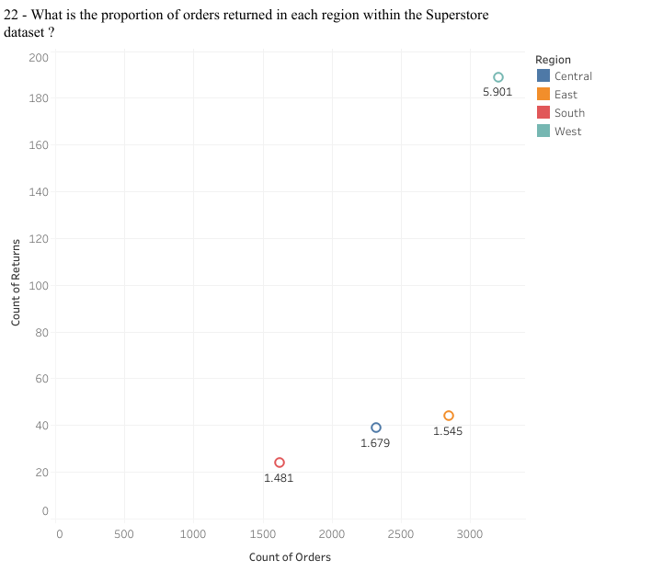Scatter charts can effectively show the relationship between two variables, making them suitable for visualizing the proportion of orders returned in each region within the Superstore dataset. The west has the highest percent of return at almost 6% with the other 3 region having a low return percent of around 1%
2. Can you compare the profit of different products for different subcategories?

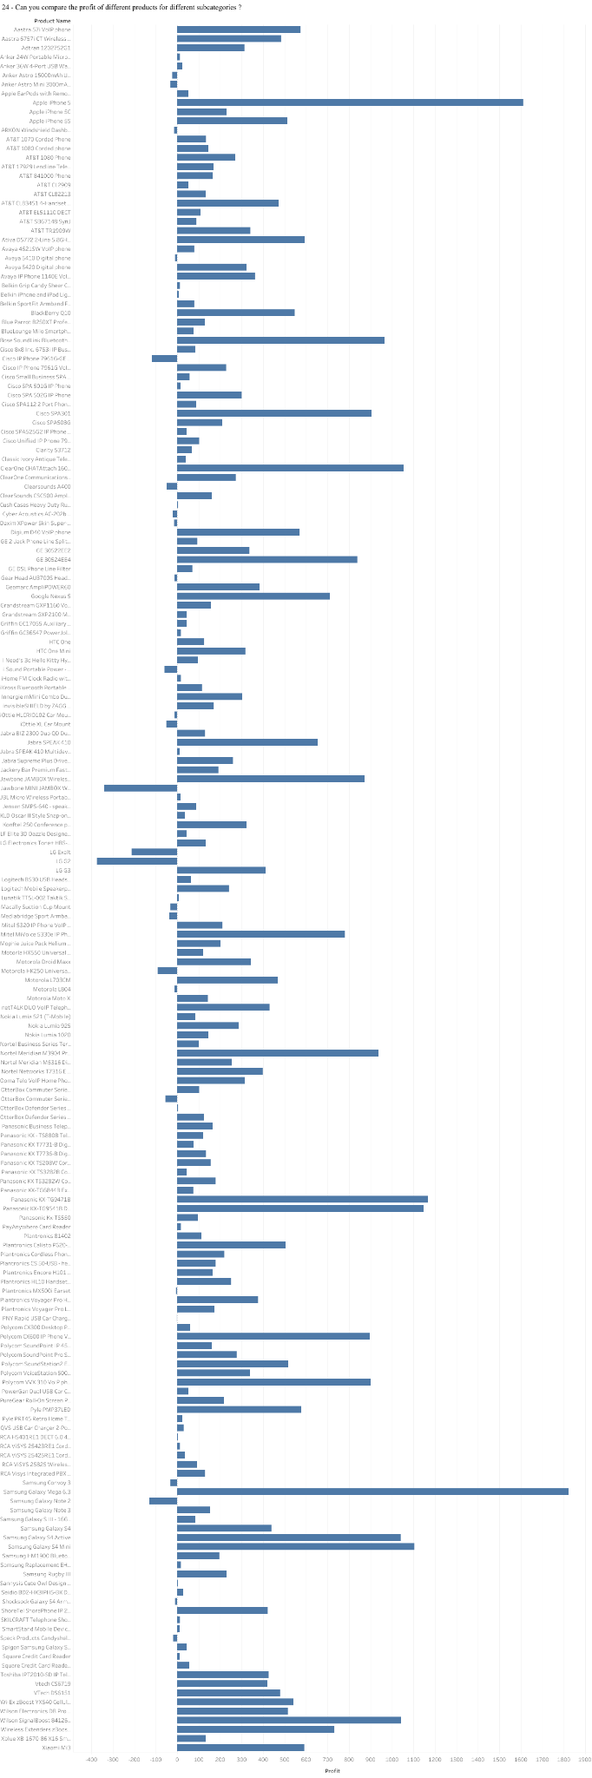

Horizontal bar charts are suitable for comparing values across different categories, making them ideal for comparing the profits of different products for different subcategories.

1. Which shipping mode is the most commonly used in the Sample Superstore dataset?

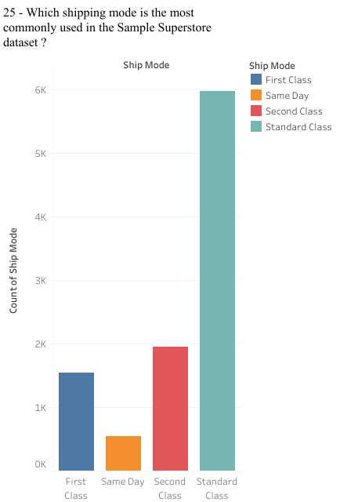

Bar charts are suitable for comparing frequencies or counts across different categories, making them ideal for determining the most commonly used shipping mode.

1. How does the sales performance of different regions evolve throughout the quarters of a year?

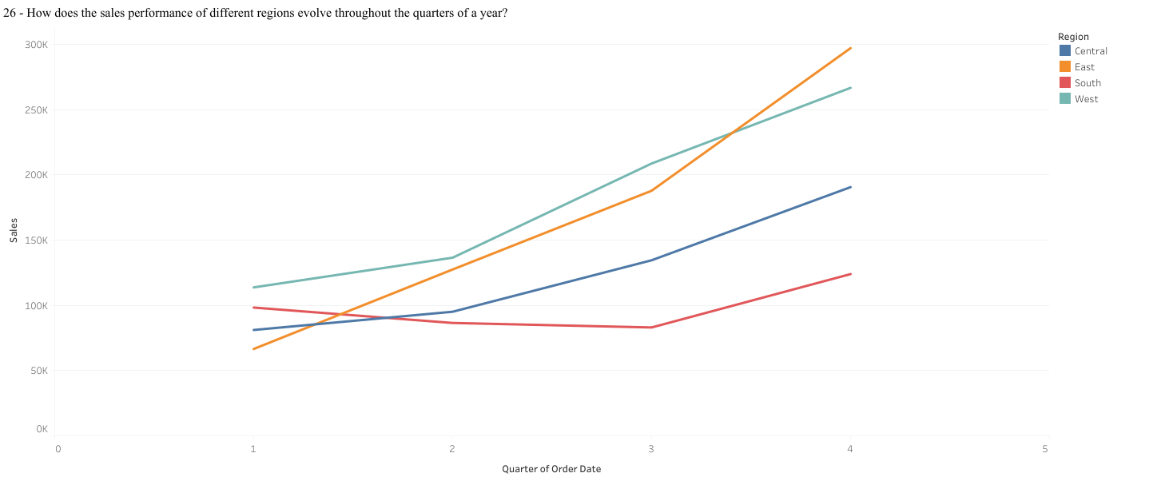

Similar to the question about monthly trends, multiple-line charts can effectively show the sales performance of different regions throughout the quarters of a year by displaying multiple lines representing each region

1. What is the distribution of order priorities across different product categories?

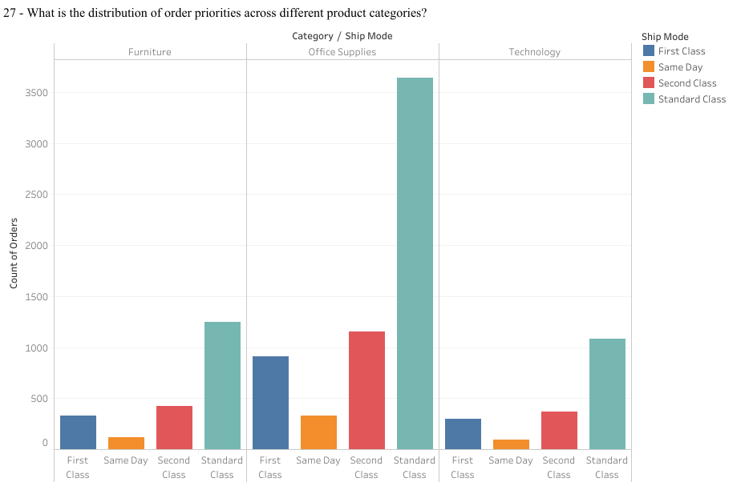

Bar charts are suitable for comparing distributions or frequencies across different categories, making them ideal for visualizing the distribution of order priorities across different product categories.

1. What is the relationship between discounts and sales?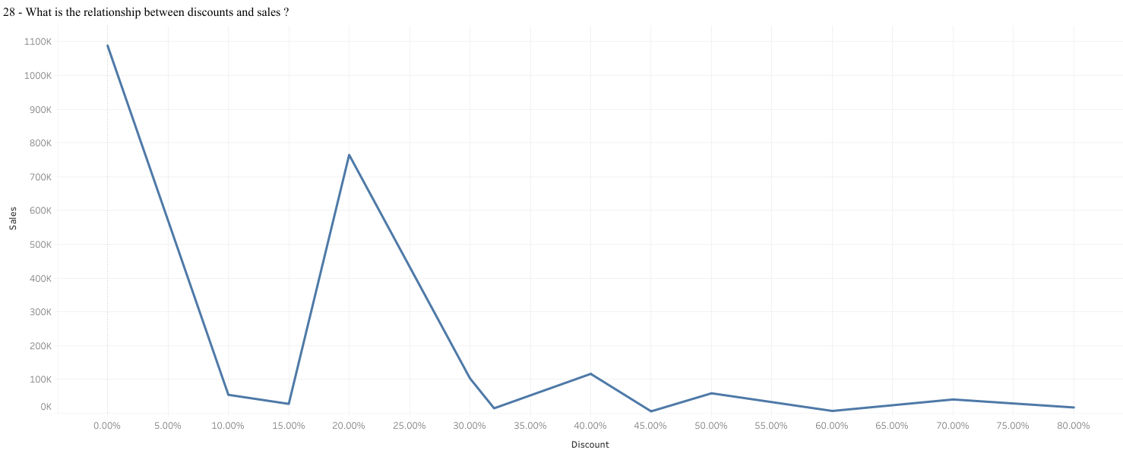

Line charts are suitable for showing trends over time, making them ideal for visualizing the relationship between discounts and sales by displaying sales trends as discount rates vary.

1. How does the average order value differ between repeat customers and new customers?

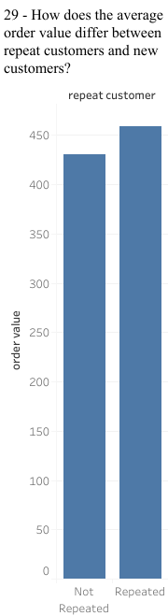

Bar charts are suitable for comparing values across different categories, making them ideal for comparing the average order value between repeat customers and new customers.

1. What is the geographical distribution of returns and its impact on overall profitability?

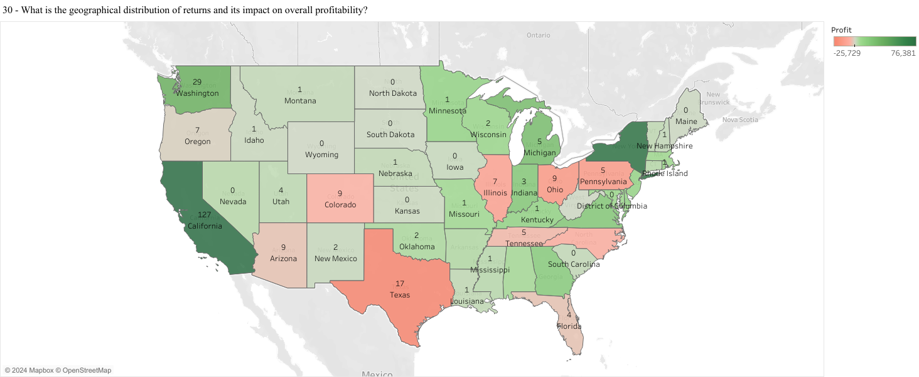

Map charts are used to visualize spatial data, making them ideal for showing the geographical distribution of returns and their impact on overall profitability.